# Technical Indicators for Crypto Trading

## In this document, we'll quickly explore the indicators we'll be using in our model to make trading decisions. It's important to remember that these indicators and our model are complementary to other analyses such as macroeconomic, fundamental and market news analysis. We reasonably assume that the market is liquid and there is enough trading volume to make this analysis.

## 1. Relative Strength Index (RSI)

The RSI measures the strength and speed of price movements over a specified period, helping to identify overbought (potential decline) or oversold (potential rise) conditions.

### Formula

1. Compute the average gain and loss over a period (commonly 14 days):

* Average Gain = Sum of gains / n
* Average Loss = Sum of losses / n

2. Compute the Relative Strength (RS):

* RS = Average Gain / Average Loss

3. Compute the RSI:

* RSI = 100 - (100 / (1 + RS))

If the RSI is above 70, we assume that the crypto asset is overbought and will probably see a correction. If the RSI is below 30, we're likely to see an increase in price. Empirically, we can see that RSI analysis is relevant in the cryptocurrency market.

## 2. Moving Average Convergence Divergence (MACD)

The MACD analyzes the difference between two exponential moving averages (EMA) to detect trend changes.

### Formula

* MACD = EMA(12) - EMA(26)
* Signal Line = EMA(MACD) over a 9-day period
* Histogram = MACD – Signal Line

A general interpretation of the MACD is that when the MACD is positive and the value of the histogram is rising, bullish momentum is increasing. When the MACD is negative and the value of the histogram is decreasing, the downward trend is increasing.

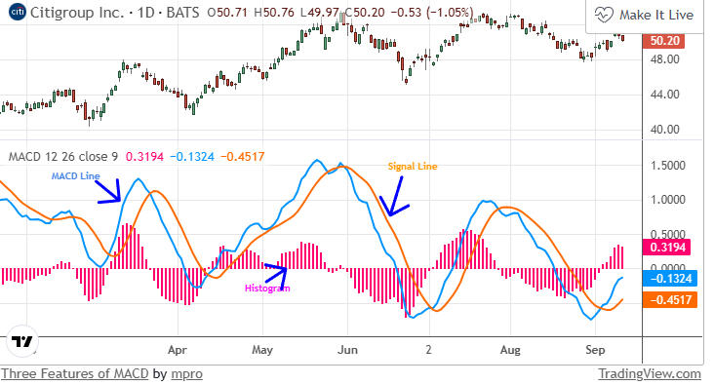

## 3. Trading Volume

Volume measures the number of transactions for a crypto asset over a specific period, indicating market interest and potential price movement.

### How to Use

1. High volume with rising prices: Strong bullish trend.

2. Low volume with stable prices: Weak interest, possible reversal.

3. Volume spikes: Potential significant price movement.

## 4. Volatility

Volatility measures the degree of variation in the price of a financial instrument over a specific period. It quantifies the risk associated with the price changes of an asset, making it a critical metric in financial analysis and trading strategies. Higher volatility typically indicates larger price swings, while lower volatility suggests more stable price movements.

For intraday trading, short-term volatility is crucial for determining entry and exit points, as well as for assessing the potential risk of trades.

**Formula**

$$σ=\sqrt{\frac{1}{N-1}\sum_{i=1}^{N}{{\left(r_{i}-\overline{r}\right)}^{2}}}$$

Where:

* $r_{i}$*: Return on day i*
* $\overline{r}$*: Mean return over N days*
* $N$*: Total number of days*